Music History Lesson Plan – Thanksgiving

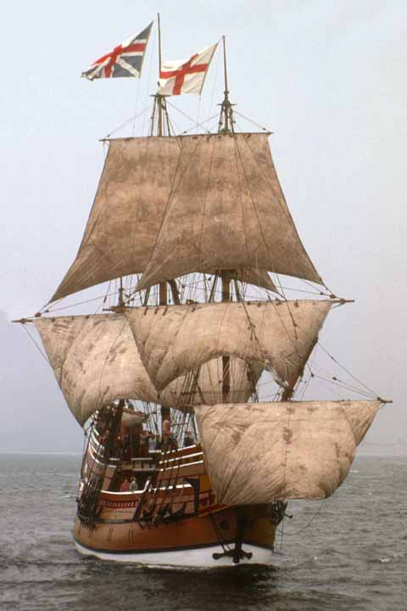
Objectives
Oregon Arts Benchmark 1.3.1 Identify an event or condition that influenced a work of art.
Oregon Arts Benchmark 1.3.2 Identify social, historical, and cultural characteristics in a work of art.

Goal – Students will be able to place Plymouth Rock in the historical context
of the Baroque music period.

Materials Needed
tMC CD’s
Pilgrims worksheet
the Music Connection Curriculum

Lesson Plan

Here in the United States, we are free to choose what kind of church we want to attend, or whether we want to attend at all. But England has an official church.

In 17th Century England, everybody paid taxes to the official church whether they wanted to or not. At times those who started other kinds of churches were put in jail.

The people we call the Pilgrims wanted to live in a place where they would have freedom to practice the religion they believed in. Many of them left England for Holland. But several years later, they decided to move to the new world.

It took a long time to get a permit from the English government to make a new colony in the Americas. There was only one other colony in the Americas, Jamestown, Virginia.

It was expensive to travel by ship to the Americas. The Pilgrims set up a partnership with some merchants in England. They would work for the merchants for 7 years when they reached America.

There were problems with their ships. Finally the Mayflower set sail from England September 16, 1620 with 102 passengers. Most of them were Pilgrims.

They were headed for Jamestown, Virginia. There they would find houses, food, and a fort.

They anchored at the Americas November 21, 1620, about 500 miles above Virginia. Today we call the place they anchored Massachusetts. There were several scouting parties sent out to find a place for a settlement.

They chose a place in late December and called it New Plymouth. The Mayflower had to return soon to England. At first they built huts of tree branches to live in. They began to build a common house for shelter. They finished the first common house in January.

Virginia can be cold in the winter, but Massachusetts is brutally cold. It was a very difficult winter. Many of the passengers began to die. That first winter, 47 of the 102 died! At the end of the first winter, only 4 mothers were alive.

The pilgrims continued to build houses.

They had some problems with the native Americans. In Europe, in England, you owned or rented property. The native Americans didn’t own property. To their thinking, nobody owned the land. If you could say that somebody owned the land, the tribe owned the land. Native Americans moved from one settlement to another during different seasons.

The pilgrims knew nothing about the native Americans. They only knew that sometimes the native Americans would fight and kill colonists. They were basically afraid of the native Americans. There were some battles. But some of the native Americans were friendly. Some of them taught the Pilgrims how to plant crops the Pilgrims had never seen like maize and squash.

More Pilgrims came on ships from England. At the harvest time in 1621, there were houses to live in. They had food stored that would get them through the next winter. Most everybody was healthy. They had a settlement that they could protect from attack.

The Pilgrims set a day after that first harvest for a feast. They attended church first, then had a feast to celebrate the harvest.

The Governor of Plymouth invited Grand Sachem Massasoit and the Wampanoag people to join them in the feast. The settlers fed and entertained the Native Americans for three days. The Native Americans went into the forest, killed 5 deer to contribute to the feast.

Two years later, an official proclamation called for a Thanksgiving feast in November. This feast was continued every year in Massachusetts. 200 years later, Abraham Lincoln made Thanksgiving Day an American tradition.

“In as much as the great Father has given us this year an abundant harvest of Indian corn, wheat, peas, beans, squashes, and garden vegetables, and has made the forests to abound with game and the sea with fish and clams, and inasmuch as He has protected us from the ravages of the savages, has spared us from pestilence and disease, has granted us freedom to worship God according to the dictates of our own conscience, Now I your magistrate, do proclaim that all ye Pilgrims, with your wives and ye little ones, do gather at ye meeting house, on ye hill, between the hours of 9 and 12 in the day time on Thursday November 29th of the year of our Lord 1623 and the third year since ye Pilgrims landed on ye Pilgrim Rock, there to listen to ye pastor and render thanksgiving to ye Almighty God for all His blessings.” William Bradford, Ye Governor of Ye Colony

Songs

“Over the River and Thru the Woods” World of Music 2.204 CD 2.5.14
“Thanksgiving” World of Music 2.202 CD 2.5.13
“A Turkey Named Bert” The Music Connection 2.263 CD 2.5.25
“We Gather Together” The Music Connection CD 4.8

© 2007-2008 Stephen R. Dalrymple

