Let’s Take Back Thanksgiving!
Eleven Day Spiritual Adventure Journal

November 17-27, 2008

Stayton Church of the Nazarene

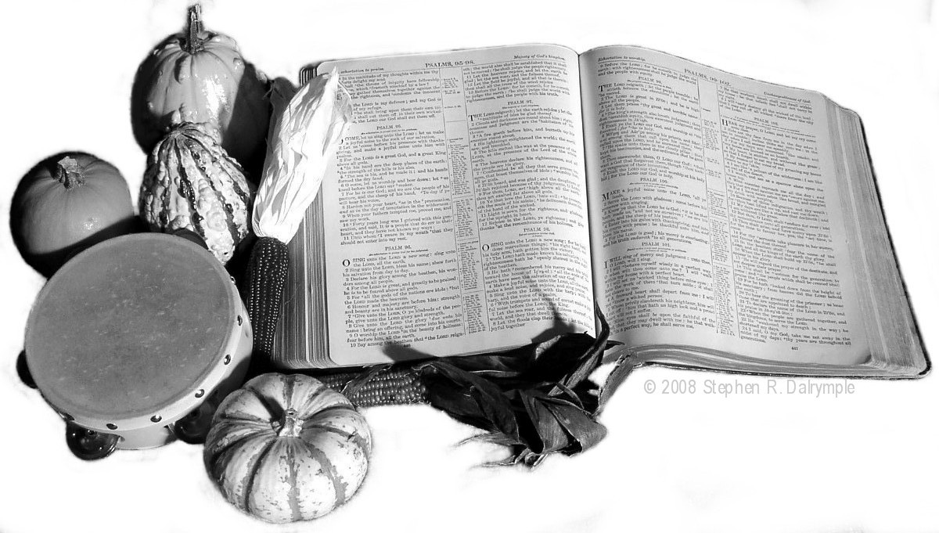

Adventure journal written by Steve Dalrymple
© 2008 Stephen R. Dalrymple
Day 1 Nov 17 Monday – Preview –Read Psalm 98

Read Psalm 98 several times.

1. Try to find the structure of the Psalm.

2. Modern versions divide the Psalm in to 3 paragraphs. Each paragraph pictures God in a different way. Can you find some key words that point to the structure of the Psalm?

3. There are many action words in the Psalm. List 7 verbs that describe the worshipper’s response to God.

4. Thought Question: Praise in the Old Testament is always a public affair. Giving thanks privately is a New Testament concept. Is there something that God has done for me recently that I ought to share in a public forum?(Record this on the Blessings List at Day 5)

Application for me today:

Prayer requests and answers:
Day 2 Nov 18 Tuesday – Our Victor Ps 98:1-3

1. Each verse has 2 verbs (action words) that tell us what God has done. What are they?
98:1

98:2

98:3

2. God is pictured as a soldier / warrior / victor in these verses. In the ancient world, it was the strength and skill of the warrior that was celebrated. The weapons were secondary to the strength of the warrior. When Scriptures speak of the arm of the LORD, they speak of His most powerful acts. To what has God put His whole strength?

3. The term “salvation” most often has physical salvation in mind in the OT. We speak of the lifeguard saving a swimmer from drowning. The term “salvation” most often has a figurative sense in the NT. We say “That saved me from a lot of embarrassment.”
How do God’s acts of salvation fit both of these categories?

4. Ancient peoples often thought of gods as territorial, with a limited range of power. How far does the LORD’s power extend?

Application for me today:

Prayer requests and answers:

Day 3 Nov 19 Wednesday – Thursday – God’s Name

God has many revealed names in the Bible. Sometimes these names are more like titles.

Elohim is a common name for God the Creator. It is a plural word (Gods) but the way it is used with a singular verb shows that when the Bible uses this term for God the Creator, Elohim has a singular meaning. (Elohim with a plural verb means gods.)

This is often called the “plural of majesty.” (for instance, the kings and queens of England speak of themselves as “we”.) But we who believe in the Triune God see a deeper meaning with the construction of a plural noun with a singular verb.

The other name for God used in Psalm 98 is Yahweh. It is used 6 times in the Psalm. This is a personal name, not just a title or generic label.

The name Yahweh is shrouded in mystery. Ancient Hebrew was written without vowels. The Hebrew scribes who added vowels took seriously the commandment not to use the name of Yahweh in a useless way. So they protected the name in an unusual way. The consonants of Yahweh (YHWH) were combined with the vowels of the term Adonai (e o a). Adonai means lord, the master of a slave.

In more modern times, a German scholar transliterated this hybrid word as “Jehovah” (pronounced yehowah in German.) To muddy things further, our modern English translations have followed the old custom of translating Yahweh as LORD (notice the capital letters) in our English Bibles.

1. In Exodus 3:13-14, God reveals the meaning of His name. What does God say that His name means?

God says “I Am.” We say “He is.” Yahweh means “He is.” God’s special covenant name is Yahweh (He is!)

2. He is! What does this mean to us? Isaiah 40:38, 41:1

3. He is! What does this mean to us? Isaiah 42:8 44:16-17, 45:5, 20-21

4. Find the 6 places in Psalm 98 where God’s personal name is used.

Prayer requests and answers:
Day 4 Nov 20 Thursday Memorize

Spend some time memorizing Psalm 98:1. Record insights you gained in the process.

Prayer Requests and answers:

Day 5 Nov 21 Friday – Ps 98:1 “He has done marvelous things.”

“In as much as the great Father has given us this year an abundant harvest of Indian corn, wheat, peas, beans, squashes, and garden vegetables, and has made the forests to abound with game and the sea with fish and clams, and inasmuch as He has protected us from the ravages of the savages, has spared us from pestilence and disease, has granted us freedom to worship God according to the dictates of our own conscience, Now I your magistrate, do proclaim that all ye Pilgrims, with your wives and ye little ones, do gather at ye meeting house, on ye hill, between the hours of 9 and 12 in the day time on Thursday November 29th of the year of our Lord 1623 and the third year since ye Pilgrims landed on ye Pilgrim Rock, there to listen to ye pastor and render thanksgiving to ye Almighty God for all His blessings.” William Bradford, Ye Governor of Ye Colony

What has God done for you since last Thanksgiving Day?

Use this thanks prompter to jot down your reasons for thanks.

Bring this to church on Sunday.

abundant harvest [material needs, blessings]

protection from the ravages of the savages [safety]

spared us from pestilence and disease [health]

granted us freedom to worship [freedoms]

presence and comfort in times of trouble [spiritual needs]
Day 6 Nov 22 Saturday – Psalm 98:1 Sing a New Song

1. What are some of the new things God makes and does?

Genesis 1:1, 11-12, etc.

Lamentations 3:23

2 Corinthians 5:17

2 Peter 3:13

2. Is it easier to sing a new song or an old song?

3. Why do you think the LORD likes “new” songs?

4. Why does God like singing? Zephaniah 3:17

Application for me today:

Prayer requests and answers:

Day 7 Nov 22 Saturday Meditate

Spend some time meditating on Psalm 98:1.

Suggested method: Read the verse over and over. Each time emphasize a different word.

For instance,

“Oh, sing to the LORD a new song!...”

“Oh, sing to the LORD a new song…

” Oh sing to the LORD a new song!...”

Jot down down some observations from your mediation.

Prayer Requests and answers:

Day 8 Nov 24 Monday – Our King Psalm 98:4-6

In many cultures throughout history the tribal leader, chief, king is chosen by physical combat. Yahweh is not only the Victor, He is the King of His people. The picture in verses 4 – 6 shifts from a new song for the Warrior/Victor to the royal music of the King.

1. Besides singing to our King (v 4 and 5), how do we raise our voices to praise the King?

2. Another type of sound joins singing and shouting. What musical instruments are mentioned?

3. The trumpet was made of metal. The horn was an animal horn, usually sheep or goat. The trumpet and horns used a cup shaped mouthpiece. The harp was of course a stringed instrument. What other instruments were used during worship in ancient Israel? Psalm 150

4. Notice that all 4 families of musical instruments are represented in Psalm 150. Explain.

5. What sounds are produced in praise? v 1, 4, 5, 6, 7, 8, 9

6. Is praise silent? What is the difference between praise and private thanks?

Application for me today:

Prayer requests and answers:
Day 9 Nov 25 Tuesday – Reflect on His Majesty

It’s time to add to your gratitude list.

In what ways has the King of the Universe provided for you since last Thanksgiving? Think about the function of the kings of old and their responsibility to their people. How has God fulfilled His Kingly responsibility to you?

Add these to the Blessings Count at Day 5.

Thought question: How have I shown my submission and loyalty to my King? How have I not shown fealty to my Sovereign?

Application for me today:

Prayer requests and answers:

Day 10. Nov 26 Wednesday – Our Judge Psalm 98:7-9

The kings of old functioned as the executive, legislative, and judicial branches of their governments. They were not only champions, warriors and kings, they were the supreme courts of their lands.

1. Why does the sea, the earth and its inhabitants, the rivers and the hills add their praise to Yahweh?

2. Why has mankind yearned for true justice throughout its history?

3. When will true justice come to the earth? Isaiah 42:1-4

4. Why will the creation rejoice when justice comes? Romans 8:18-22

Application for me today:

Prayer requests and answers:
Day 11 Nov 27 Thursday – Psalm 98:1-9

Read the Psalm

Review and add to your Blessings Count at Day 5

Spend some time thanking God for the things listed on your Blessings Count

Application for me today:

Prayer requests and answers:

