Let’s Take Back Thanksgiving!
Eleven Day Spiritual Adventure Journal

November 17-27, 2008

Stayton Church of the Nazarene

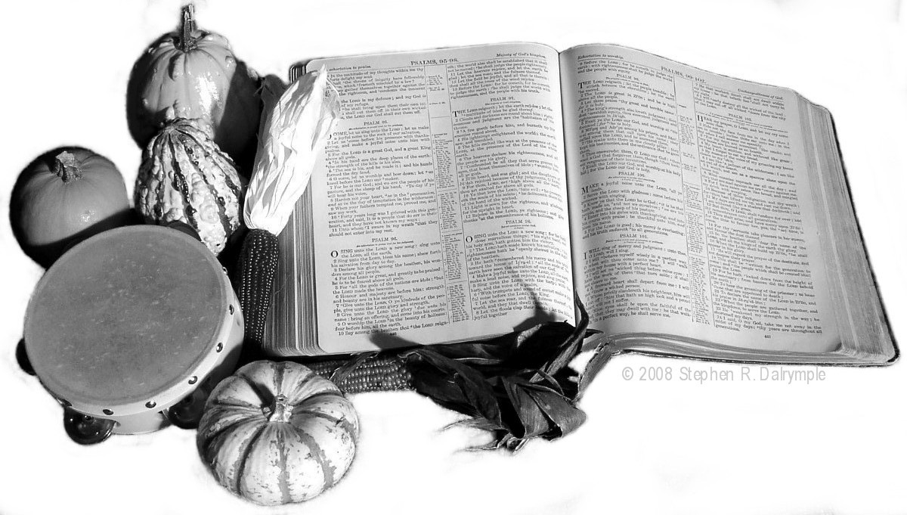

Adventure journal written by Steve Dalrymple
© 2008 Stephen R. Dalrymple

__________________________________________

name xxxxxxx

