Let’s Take Back Thanksgiving!

Ask the ordinary person (or child) why they look forward to Thanksgiving and you will hear something like “turkey!” football!” or “4 days out of school!”

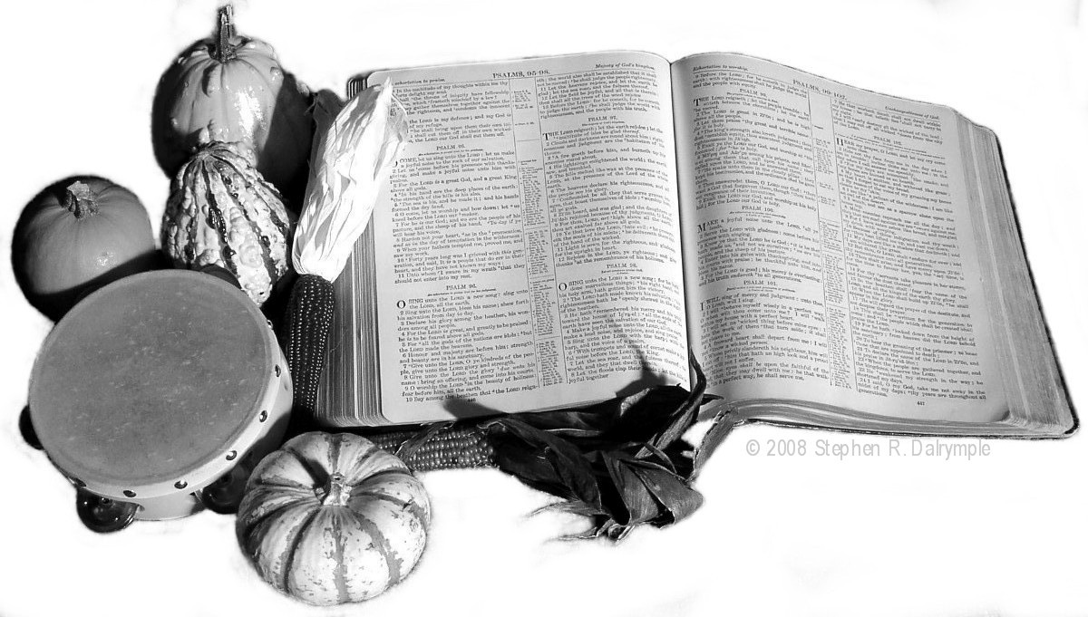
Somehow “gratitude” and “giving thanks” and “praise” seem far from our minds when the actual day comes. It isn’t even politically correct anymore to speak of the Pilgrims in a favorable light.

In 1623 after the Pilgrims had survived 3 difficult years in the new world, they gathered to give thanks. The day began with a morning worship service. The Pilgrims went to church. Then the Pilgrims had a feast, celebrating the blessings they knew after barely surviving their first years in their new home.

Let’s Take Back Thanksgiving this year from the watered down version the enemy has substituted for the real thing!

11 Day Spiritual Adventure – Study Psalm 98 with us for 11 days leading up to Thanksgiving. Record the things your Father has done since last Thanksgiving Day. Prepare your heart for a feast that celebrates blessings.

Celebrate with us the Sunday before Thanksgiving. Share a worship service planned around Psalm 98 specifically designed for you to share publicly what God has done for you in the last 12 months.

Demonstrate your gratitude by giving to a project that will help those less fortunate than yourself.

Let’s Take Back Thanksgiving!

© 2008 Stephen R. Dalrymple
Let’s Take Back Thanksgiving!

Ask the ordinary person (or child) why they look forward to Thanksgiving and you will hear something like “turkey!” football!” or “4 days out of school!”

Somehow “gratitude” and “giving thanks” and “praise” seem far from our minds when the actual day comes. It isn’t even politically correct anymore to speak of the Pilgrims in a favorable light.

In 1623 after the Pilgrims had survived 3 difficult years in the new world, they gathered to give thanks. The day began with a morning worship service. The Pilgrims went to church. Then the Pilgrims had a feast, celebrating the blessings they knew after barely surviving their first years in their new home.

Let’s Take Back Thanksgiving this year from the watered down version the enemy has substituted for the real thing!

11 Day Spiritual Adventure – Study Psalm 98 with us for 11 days leading up to Thanksgiving. Record the things your Father has done since last Thanksgiving Day. Prepare your heart for a feast that celebrates blessings.

Celebrate with us the Sunday before Thanksgiving. Share a worship service planned around Psalm 98 specifically designed for you to share publicly what God has done for you in the last 12 months.

Demonstrate your gratitude by giving to a project that will help those less fortunate than yourself.

Let’s Take Back Thanksgiving!

© 2008 Stephen R. Dalrymple

